Background. The SC Optimization and CPFR (Program teams within Dave’s org) teams have completed foundational planning to support integration of these programs into CPH. While CPH leadership agrees that this data and functionality should ultimately reside within the platform, there is currently a gap in clearly defined ownership and dedicated technical resources to execute the end-to-end build. The purpose of this meeting is to review the high-level scope of work and align on ownership across teams to determine whether sufficient engineering and program/product capacity exists to successfully onboard both CPFR and Vendor Compliance into CPH within the targeted timeline.

Current Status. The Program team developed detailed user stories, business requirements documents, and supporting wireframes outlining the intended functionality and user experience (Link to docs in Appendix 1.0). These materials were reviewed with both the CPH and Replenishment Technology teams to ensure alignment on scope and feasibility on 3/5. Following that alignment, resources were secured from the CPH Design team to develop UX designs across three distinct views: Vendor Report Management, User Management, and the Main CPH Interface, with designs expected to be completed by 4/10 (see appendices). Upon finalization, engineering resources will be required to code the approved UI components, enable vendor assignment to specific reports, allow vendors to enroll in or subscribe to designated reports, and build and integrate the necessary underlying data structures within CPH to fully support the intended functionality.

Ownership of Engineering
Replenishment Technology Team. The Replenishment Technology team will be responsible for backend data infrastructure and overall data readiness to support integration into CPH. This includes ensuring data accuracy and completeness, building and maintaining the required data architecture, establishing traceability and auditability, meeting performance standards for speed, reliability, and scalability, and ensuring that all data outputs align with CPH platform requirements. Their primary objective is to deliver data that is production ready, standardized, and fully prepared for seamless integration and consumption within CPH.

CPH Team. The CPH team will be responsible for front-end UI development and implementation. This includes coding the approved UX designs, developing the necessary front-end functionality, and ensuring that the overall user experience aligns with CPH product standards. The team will leverage its front-end development expertise, including platform-specific frameworks and JavaScript capabilities, to maintain consistency and quality across the broader CPH ecosystem. The framework being implemented is intentionally designed to be scalable and extensible, enabling the broader business to leverage this structure to share additional data sets in the future and drive expanded cross-functional value.

Summary: The Replenishment Technology team will own preparing and structuring the data for SPARK, ensuring it is accurate, standardized, and available in an integration-ready format that is easy to consume. The CPH team will be responsible for coding the approved UI designs and integrating that data into the appropriate components within CPH, including CSV file generation, Tableau scorecard integration, and supporting the core internal functionality and workflows of the CPH platform.

Program/Product Ownership
Optimization/CPFR Team. This team is responsible for defining the functional vision and operational framework required to meet the needs of both In Stock and Vendor partners. This includes gathering stakeholder input to ensure the voice of the customer is embedded in the design, clearly defining priorities, and establishing functional requirements. The team also owns the development of the Business Requirements Documents for each module, which serve as the foundation for engineering assessment and scoping by Erdem’s team. The Optimization and CPFR team are accountable for ensuring the final solution aligns with business objectives and delivers against the defined specifications. Additionally, CPFR team is coordinating build-out of semantic data layers to simplify data views and connections in CPH.

Erdem’s Team: This team serves as the bridge between the Product team and CPH Engineering. They are responsible for reviewing and assessing the BRDs to translate business requirements into technically sound, scalable solutions. With deeper expertise in system architecture and underlying data structures (e.g., SPARK), they evaluate each module and sprint to ensure feasibility, identify gaps, and surface critical nuances that must be addressed prior to development. This team acts as the technical vetting layer, ensuring requirements are properly structured and de-risked before engineering begins, increasing the likelihood of delivering the solution correctly on the first build.
Roadblocks. Currently, there are no formal engineering commitments from the CPH team. While the Replenishment Technology team has reviewed the proposed framework with CPH, and there has been acknowledgment that this work may logically reside within their domain, no formal commitment has been made to execute the development. The scope of work represents a significant engineering effort, given the level of coding and functionality required to deliver the intended capabilities.

Successful execution of this project will require active partnership and dedicated engineering support from the CPH team, despite their existing 2026 roadmap commitments. We need our leadership’s support to secure a 2026 engineering commitment from CPH leadership, and alignment from the Replen Tech team on the engineering support required. The potential paths forward include leveraging existing CPH engineering resources, securing incremental engineering capacity to support the build, deferring the initiative to 2027 to allow CPH to formally scope and incorporate it into the roadmap, or reevaluating the CPH integration strategy and instead investing in further optimization of the existing legacy mechanisms.

What happens if we defer it to 2027 or never do this?
If we defer to 2027, or choose not to move forward, we will remain in a fragmented, email driven model that delays entitlement capture, slows efficiency gains, and limits our ability to scale.
- It limits our ability to scale the Chargeback program to additional vendors given the email volume, escalations, and disputes.
- Vendor stakeholders will continue receiving more than 55 emails per week without segmentation by role or function. Supply and replenishment owners will keep receiving warehouse violations and other non-relevant communications, creating noise that slows execution and dilutes accountability.
- Vendors will remain slower to act because they must manually sift through high email volume to identify what is actionable. With limited capacity across supply, EDI, operations, demand, and replenishment teams, response speed and quality will remain constrained.
- We will remain reliant on legacy communication mechanisms that lack structured visibility, subscription management, and role-based access. Continued manual email updates introduce ongoing risk of outdated or incorrect distribution lists.
- Chewy’s vendor engagement model is intentionally shifting toward CPH and away from CRM in 2026 and 2027 for engagement, action, and ticketing. Aligning to this direction ensures a unified vendor experience rather than maintaining parallel systems, and positions us on par with structured supplier portals like Amazon Vendor Central and Walmart Luminate.
- The cohort of vendors served by CPFR reporting has expanded from 1,680 same-time last year to over 3,200 active vendors with ‘line-of-sight' to 4,175. At this expanded scale, the maintenance burden and risk of service interruption has grown exponentially.

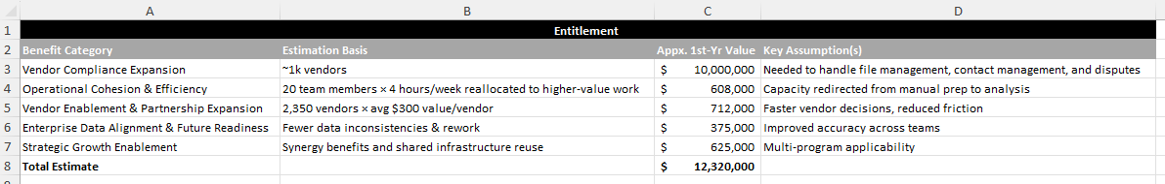

What Ideal Next Steps look like
Replenishment Technology Team. The Replenishment Technology team will deliver an initial draft outlining the scope of work required for SPARK data readiness by March 27. This draft will detail the technical requirements necessary to structure and prepare the data in the required format. Once initiated, this work is expected to take several months to complete due to the architectural build, validation processes, and overall data readiness requirements.

CPH Design Team. The CPH Design team is expected to deliver three UX design views by April 10 for stakeholder review. These deliverables will include the user experience and interface designs only and will not include the underlying engineering or functional code required to operationalize the features. CPFR is also interacting with UX to plan two wireframe views, ETA TBD, and will provide mapping to SC-BIE semantic data layers.

Program/Product Teams. Once a dedicated CPH engineer is assigned, a resource from Erdem’s team will formally engage on the project. This team will review the BRDs, establish a Jira and tracking structure, and begin technical assessment of the scoped work. They will provide guidance on adjustments, enhancements, and system considerations to ensure engineering receives clearly defined and technically sound requirements. In parallel, the Optimization and CPFR teams will continue meeting regularly with In-Stock leadership to review current modules, gather feedback, prioritize enhancements, and develop BRDs aligned to the broader product roadmap and delivery timeline.

Ideal State Execution Plan. CPH engineering would begin coding in mid-April, starting with Modules 1 and 2 (report configuration and user management), which can progress independently of SPARK data readiness. This phase is expected to take several months given the required functionality. Once complete, we will assess sequencing for onboarding metrics and prioritize either CPFR or Vendor Compliance metrics based on data readiness and implementation feasibility. CPFR data-layer (as an upstream dependency for CPFR data views) is on-track for deployment by 2026-03-31. Timely alignment on engineering resources is critical to maintaining momentum, enabling parallel execution, reducing delivery risk, and positioning the platform for scalable expansion.

Appendix 1.0: Links to User Stories, Business Requirements Documents, and Supporting Wireframes
- Vendor Compliance - Documents - Leadership Documents - All Documents

Appendix 1.1: UX Design 1 = allow ONLY Chewy stakeholders (CMs) to sign vendors up for programs.
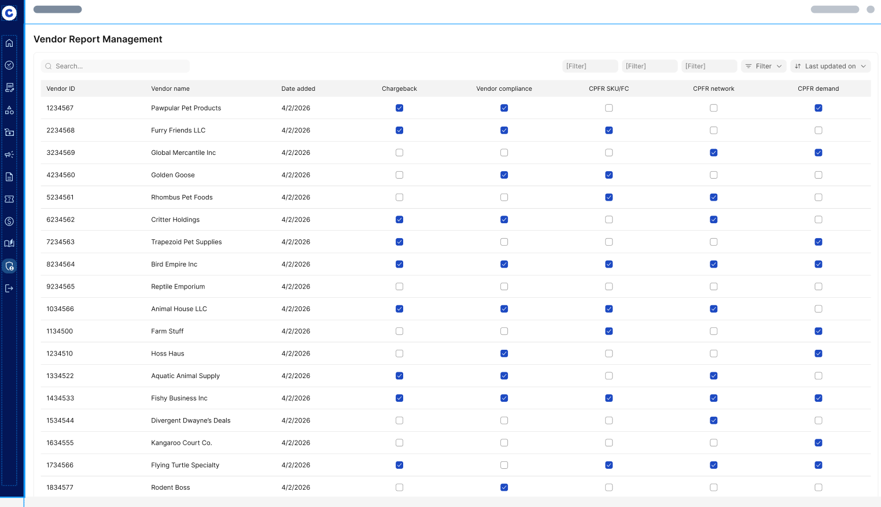

Appendix 1.2: UX Design 2 = Based on the UX Design 1 configuration, this enables the vendor-facing option to manage report distribution. Vendors self-manage their contacts and control who receives report emails.
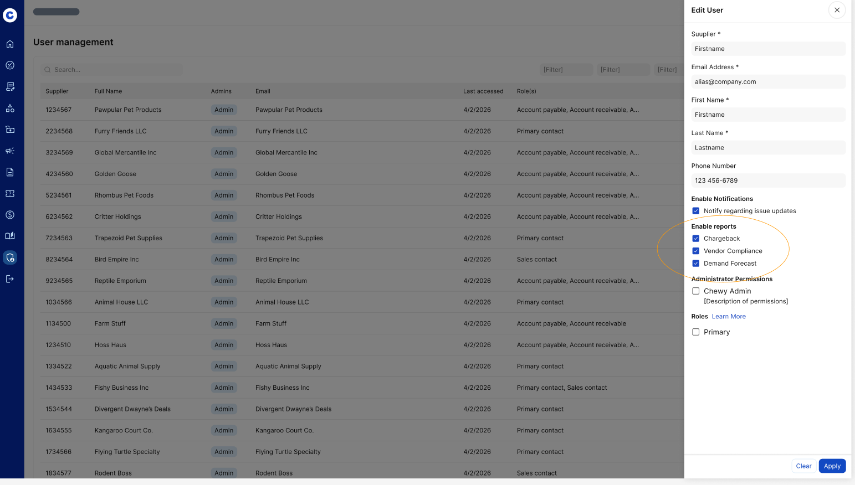

Appendix 1.3: UX Design 3 = The main CPH interface that allows the vendor to navigate the top tabs to access the reports or Tableau to access their data and alerts.
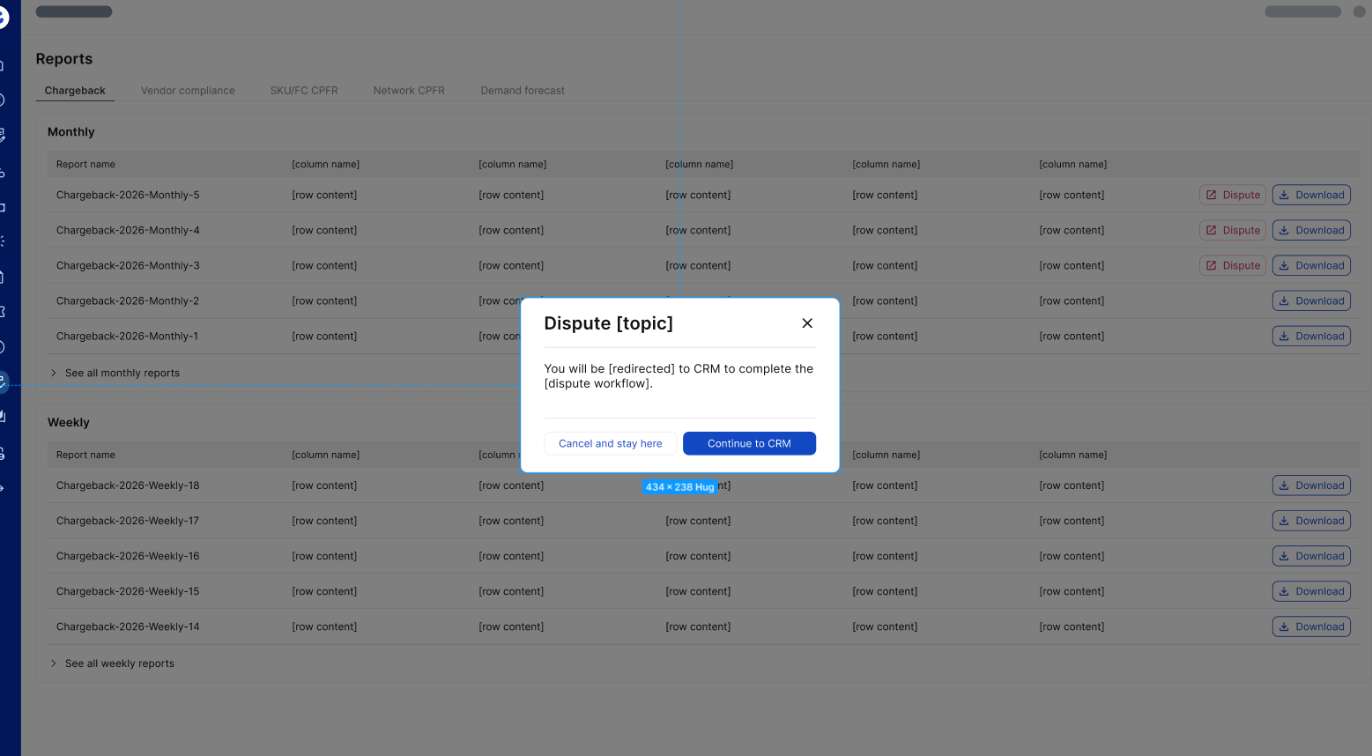
Appendix 1.4: CPFR UX Wireflow = Conceptual flow and user interactive journey (subject to developmental change)

